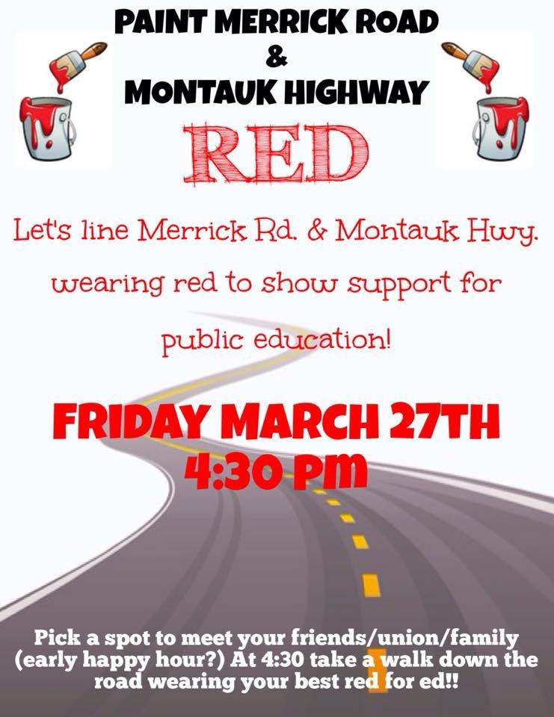

Partial List of Gathering Points
(Some locals are planning to meet at the following locations, but all are welcome at any location.)
- Left Coast Kitchen, 1810 Merrick Rd, Merrick (BMUST)
- Valley Stream Town Pool, Merrick Rd., 1 block east of Fletcher Ave., Valley Stream (VSTA)
- McQuades, 275 Merrick Rd, Lynbrook (Lynbrook TA)
- J. Paul's Terrace Cafe, 239 Merrick Rd, Oceanside (Oceanside TA)
- Vine Wine Bar, 2259 Merrick Rd, Merrick (North Bellmore TA)
- Corner of Merrick Road and Wantagh Ave., Wantagh (Westbury TA)
- Burns Park, 4990 Merrick Rd, Massapequa Park
- Massapequa HS, 4925 Merrick Rd, Massapequa (Massapequa FT)
- NEFCU, 556 Merrick Rd, Rockville Centre (RVCTA)
- Bayview Avenue Elementary School, S. Bayview Ave. and Merrick Road, Freeport (Freeport TA)
- Great South Bay Shopping Center, 835 Montauk Hwy, West Babylon
- Islip Town Hall, 655 Main St, Islip

