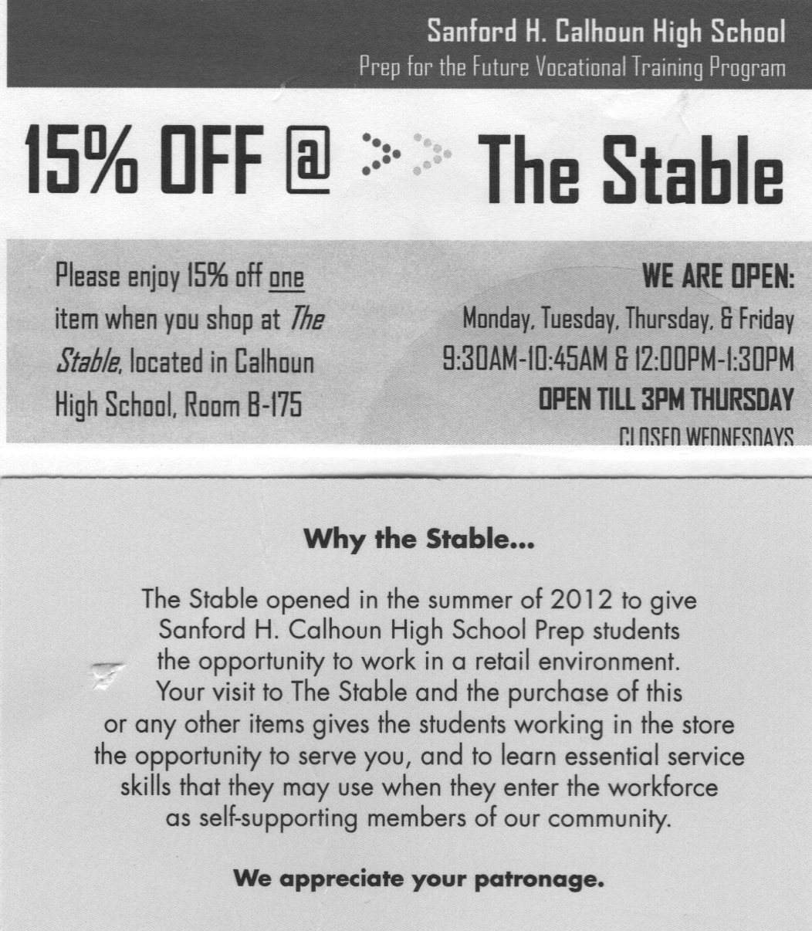

* **Workshop F- Vocal Room**

Competitive Employment Options

Marlene Johnston, ACCES-VR

Suzanne Feiner, AHRC

Diane Macaluso, Ken’s Krew

* **Workshop G – Band Room**

Person Centered Employment & Supportive Services (Pathways, Employment Training Program-ETP)

Terri Hughes, South Oaks

Bonnie Holtzman, YAI

Michelle Costa, OPWDD,ETP

* **Workshop H – Little Theatre**

Documentation for Supplemental Security Income ***One Session Only***

Dr. Puchta, Long Island Center for Independent Living

* **Workshop I– East Cafeteria**

**The Person Centered Planning Process & The Wheel Power Experience-** ***One Session Only***

B*ridg*et Cariello **SANYS** Mgt. Team, and

Beverly Burke Grassroots Organizer

* **Workshop J – West Cafeteria**

Students Workshop ***One Session Only***

Student/Alumni Speaker, Self-Advocacy New York State

Student/Alumni Speaker, Prep for the Future

Student/Alumni Speaker YAI

Student/Alumni Speaker Life’s WORC

Student/Alumni Speaker, Ken’s Krew

Student Speaker, ETP

Student/Alumni Speaker, FREE

Student/Alumni Speaker, South Oaks

* **Workshop A – Auditorium**

OPWDD (Front Door), Family Support Services and Non-Medicaid Service Coordinator

Jennifer Huddleston, Head Injury Association

Danielle Wellington, Life’s WORC

* **Workshop B – Room 111**

Medicaid Service Coordination, Waivers, Recreation, Crisis Services

Kristi Markus, Head Injury Association

Gayatri Dubey, IRI

Marsha Marino, Community Independence Mainstreaming Associates

* **Workshop C- Room 102**

Special Needs Trust and Legal Guardianship

Andrew Cohen Esq.   
Law Office of Andrew Cohen

* **Workshop D- Room B172**

Self-Determination & Self-Directed Services  
Barbara Morrell, Long Island Advocacy Center

John Innis, Positive Behavior Support Community Foundation, Inc.

Alison Giangregorio, Self-Direction Broker

* **Workshop E** – **Room** **B176**

Community Pre-Vocational/Day Habilitation Options

Jessica Gallone, FREE

Florence Fage, Life’s WORC

## **Tuesday, January 31, 2017**

## **6 p.m. – 9 p.m.**

## **Calhoun High School**

## **1786 State Street**

## **Merrick, NY 11566**

## **bellmoremerricksepta@gmail.com**

## ***Please complete the registration online at:***

## <https://goo.gl/forms/AV2ko0ggpa3ZB0GX2>

## ***or mail to the address above or email:*** [**bellmoremerricksepta@gmail.com**](mailto:bellmoremerricksepta@gmail.com)

## **By December 23rd, 2016**

###### Registration for 1/31/2017 Transition Fair:

###### Parent Name: _____________________________________________

###### Student Name:____________________________________________

###### Professional Name:______________________________________

###### School District:____________________________________________

###### Email address:____________________________________________

###### Telephone # ______________________________________________

#### Bellmore Merrick Central High School District SEPTA and Community Parent Center present:

#### *10th Annual Transition Fair 2017:*

#### *From Eligibility to Employment and Beyond!*

Pre-Vocational Training and Day Programs (pick session below*): First Session 7:05 – 7:25 ☐ Second Session 7:30 – 7:50 ☐ Third Session 7:55 – 8:15 ☐

ACCESS-VR and Employment Programs (pick session below*): First Session 7:05 – 7:25 ☐ Second Session 7:30 – 7:50 ☐ Third Session 7:55 – 8:15 ☐

Travel Training and Able Ride (pick session below*): First Session 7:05 – 7:25 ☐ Second Session 7:30 – 7:50 ☐ Third Session 7:55 – 8:15 ☐

Student/Alumni Workshop (First and Second sessions are *only* for individuals choosing services. Third session is for families and professionals, too): First Session (individuals only) 7:05 – 7:25 ☐ Second Session (individuals only) 7:30 – 7:50 ☐ Third Session (families and professionals) 7:55 – 8:15 ☐

***Bring this coupon to the***

**January 31, 2017**

***Transition Fair and***

***get 15% off when you shop at***

***The Stable***

***Bellmore-Merrick CHSD SEPTA is here for students and parents of students in our two district middle schools, three district high schools, Meadowbrook Alternative Program and in out-of-district placements who have either 504 plans, individualized education plans or other learning needs that do not fit squarely in the mainstream and the teachers, staff and administrators who teach them. Contact us at: bellmoremerricksepta@gmail.com or friend us on facebook at bellmore merrick septa***

***bellmore merrick septa***

**Directions to Calhoun High School**

**1786 State Street, Merrick, NY 11566**

**from Southern State Parkway:**

Take Meadowbrook Road Exit 23.

Go 0.1 mile.

Turn left on Meadowbrook Road.

Go 1 mile.

Take left on Webster Avenue.

Continue straight into rear parking lot.

***Enter school from rear parking lot at rear doors.***

**Directions to Calhoun High School**

**1786 State Street, Merrick, NY 11566**

**From Meadowbrook Parkway:**

Take Exit M7E (Babylon Tpke., N. Merrick)

Stay right onto Babylon Turnpike.

Go 0.4 mile

Take left on Meadowbrook Road.

Go 0.7 mile.

Take right on Webster Avenue.

Continue straight into rear parking lot.

***Enter school from rear parking lot at rear doors.***

*Bellmore Merrick Central High School District SEPTA and Community Parent Center present: 10th Annual Transition Fair from Eligibility to Employment and Beyond!*

**Tuesday January 31, 2017   
6 p.m. – 9 p.m.**   
Calhoun High School

1786 State Street

Merrick, NY 11566

**Transition Night Agenda**

6:00pm-7:-00pm – Open Registration

6:20pm-6:35pm- Performance by Express Yourself!

6:35pm-6:45pm- Opening Remarks

6:45pm-7:00pm- Parent and Student Speakers

7:05-9:00pm Workshops

**Pick 1 or 2 workshops that interest you! Workshops A-G are 30 minutes long, so you can pick any two. Workshops H, I, J are 1 hour 15 minutes long so you can only pick one. Agency booths will remain open 6-9. duringtworkshops.**

|  |
| --- |
|  |